COVID-19 Global Trend Analysis

1. Project Overview
This project analyzes the global spread of COVID-19 using daily country-level case data spanning January 22, 2020 to July 27, 2020. The goal is to track infection trends, compare regional impact, and uncover patterns in confirmed cases, deaths, recoveries, and active cases to support public health monitoring and reporting.
2. Dataset Summary
Rows: 49,068 — Columns: 10 — Key Features:
- Location details (Province/State, Country/Region, Lat, Long, WHO Region)
- Time series (Date — daily records from Jan 22 to Jul 27, 2020)
- Case metrics (Confirmed, Deaths, Recovered, Active)
- Coverage: 187 countries across 6 WHO regions (Africa, Americas, Eastern Mediterranean, Europe, South-East Asia, Western Pacific)
- Missing Data: 34,404 values in Province/State column (expected — most countries don't report at province level, so this is structural, not an error)
3. Exploratory Data Analysis using Python
We began with data preparation and cleaning in Python:
- Data Loading: Imported the dataset using pandas.
- Initial Exploration: Used df.head(), df.info(), and df.describe() to check structure and summary statistics.
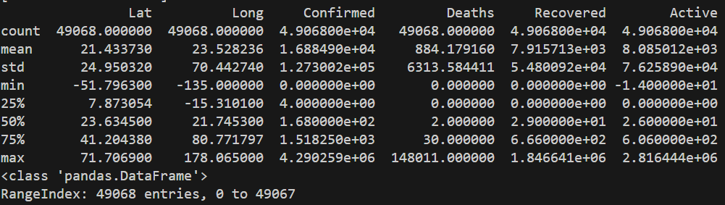
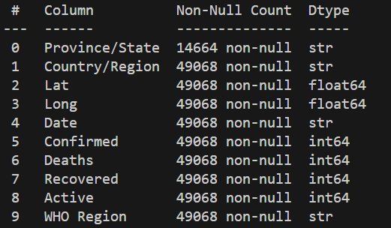
- Missing Data Handling: Checked for null values with df.isnull().sum(); imputed missing Province/State values by filling them with the corresponding Country/Region (since most countries don't report at province level).
- Column Standardization: Renamed columns to snake_case (replaced spaces and slashes, lowercased) for consistency and readability.
- Duplicate Check: Verified no duplicate rows existed in the dataset.
- Date Formatting: Converted the date column to datetime type, then reformatted to dd/mm/yyyy for consistency.
- Data Consistency Check: Identified negative values in the active column caused by inconsistent source reporting; recalculated active = confirmed - deaths - recovered and clipped any remaining negatives to 0 to eliminate logically invalid case counts.
- Category Validation: Confirmed 187 unique countries and reviewed the 6 WHO region categories for consistency.
- Database Integration: Connected the Python script to MySQL Workbench via SQLAlchemy and loaded the cleaned DataFrame into the covid_19 database for SQL analysis.
4. Data Analysis using SQL
1. Top 10 countries by confirmed COVID-19 cases — Ranks countries by total confirmed case count to identify the most impacted nations.
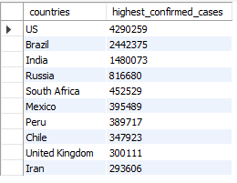
2. Top 10 countries by COVID-19 deaths — Identifies the countries hit hardest in terms of total death count.
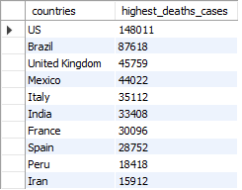
3. Global case summary (latest date) — Snapshot of worldwide confirmed, recovered, active, and death totals as of the most recent reporting date.
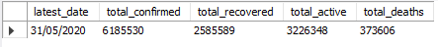
4. WHO region with highest confirmed cases — Ranks WHO regions by total confirmed cases to find the most affected region.
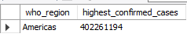
5. Countries with over 100,000 confirmed cases — Filters countries that crossed the six-figure case threshold.
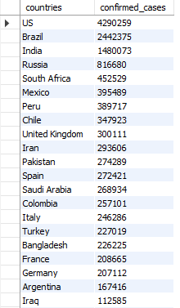
6. Mortality rate by country — Calculates death rate (Deaths ÷ Confirmed × 100) to compare case severity across countries.
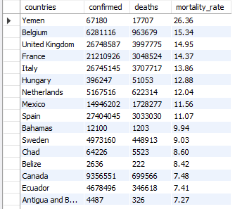
7. Recovery rate by country — Calculates recovery rate (Recovered ÷ Confirmed × 100) to compare recovery effectiveness across countries.
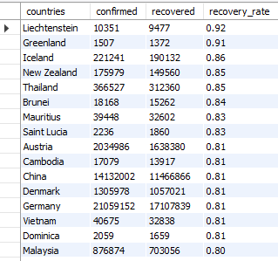
8. Countries with highest active cases — Ranks countries by current active (ongoing) case load.
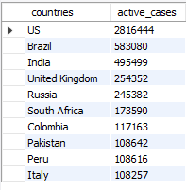
9. Country count by WHO region — Counts how many countries fall under each WHO region.
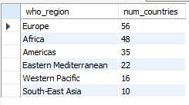
10. Daily trend of confirmed cases worldwide — Tracks the day-by-day growth of global confirmed cases over time.
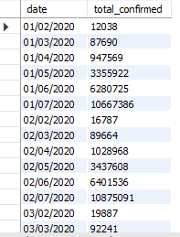

5. Dashboard in Power BI
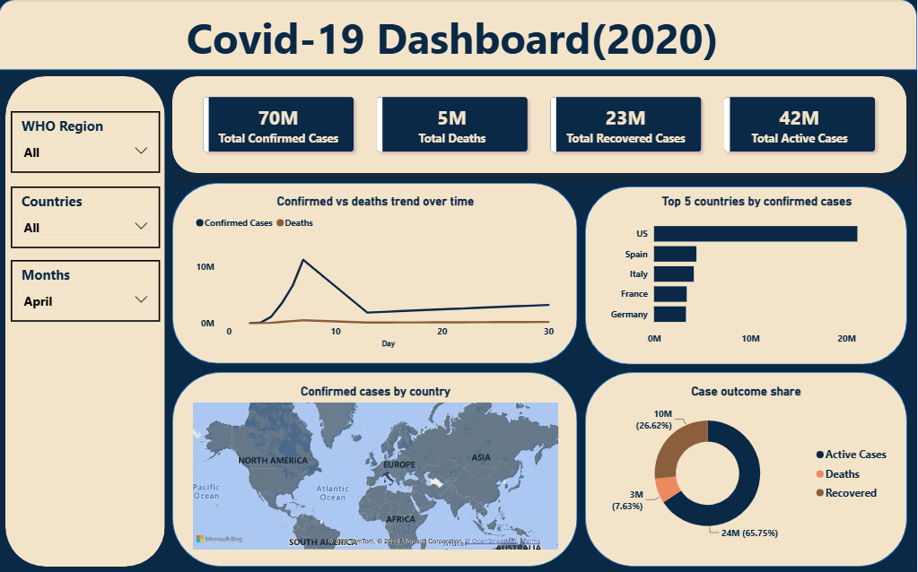

6. Recommendations
- Focus resources on high-burden regions – Send more medical support and supplies to WHO regions and countries with the highest confirmed and active cases.
- Track mortality rate closely – Countries with high death rates need better healthcare response and faster treatment.
- Monitor active case trends daily – Watch countries where active cases are still rising to catch new outbreaks early.
- Learn from high recovery countries – Study countries with strong recovery rates and copy their strategies.
- Prepare for regional spikes – Use the WHO region breakdown to plan ahead for areas that may see case surges next.
- Keep data updated regularly – Since case numbers change daily, refresh the dashboard often to support quick decisions.

